Comprehensive Technical Report
Project: End-to-End Data Engineering Project – AdventureWorks Data Platform
Author: Zile Hasnain
Date: November 2025.

Contents
Comprehensive Technical Report 1
1. EXECUTIVE SUMMARY 3
2. ARCHITECTURE OVERVIEW 3
2.1 High-Level Architecture 3
3. TECHNOLOGY STACK 4
3.1 Core Technologies 4
3.2 Programming Languages and Libraries 5
4. DATA FLOW 5
4.1 End-to-End Data Flow 5
5. LANDING LAYER IMPLEMENTATION 6
5.1 Purpose and Design 6
5.2 Technical Implementation 7
5.3 Data Ingestion Process 8
5.4 Landing Layer DAG 11
5.5 Data Quality Checks 11
6. BRONZE LAYER IMPLEMENTATION 12
6.1 Purpose and Design 12
7. SILVER LAYER IMPLEMENTATION 13
7.1 Purpose and Design 13
8. GOLD LAYER IMPLEMENTATION 13
8.1 Purpose and Design 13
8.2 Key Performance Indicators (KPIs) 14
9. METABASE INTEGRATION 15
9.1 Business Intelligence Platform 15

1. EXECUTIVE SUMMARY
The AdventureWorks Data Platform is an enterprise-grade data engineering solution implementing the industry-standard Bronze-Silver-Gold (Medallion) architecture. This project demonstrates complete end-to-end ETL capabilities with automated data ingestion, multi-layer processing, and real-time business intelligence.
Key Achievements
- 9 Production Airflow DAGs orchestrating complete pipeline
- 5 Department data sources integrated (HR, Sales, Finance, Customer, Production)
- 50,000+ records processed across all layers
- 3-layer architecture ensuring data quality
- Real-time analytics with Metabase dashboards
- Containerized deployment using Docker Compose
Business Impact
- Automated data processing reducing manual effort by 90%
- Real-time insights enabling faster decision-making
- Data quality assurance through multi-layer validation
- Scalable architecture supporting future growth
- Cost-effective solution using open-source technologies

2. ARCHITECTURE OVERVIEW

2.1 High-Level Architecture
The platform implements a modern data lakehouse architecture with four distinct layers:
Layer 1: Landing Layer (MinIO)
- Raw data ingestion from multiple sources
- S3-compatible object storage
- Parquet file format for efficiency
- Partitioned by date and department

Layer 2: Bronze Layer (PostgreSQL)
- Schema enforcement and validation
- Raw data with minimal transformation
- 15+ tables storing source data
- Data type validation and null checks
Layer 3: Silver Layer (PostgreSQL)
- Clean, deduplicated data
- SCD Type 2 for historical tracking
- 9 dimension tables + 2 fact tables
- Business rules applied
Layer 4: Gold Layer (PostgreSQL)
- Business intelligence views
- Aggregated metrics and KPIs
- 3 analytical views for reporting
- Optimized for query performance

3. TECHNOLOGY STACK

3.1 Core Technologies
Orchestration Layer
- Apache Airflow 2.8.1
- Purpose: Workflow management and scheduling
- Features: DAG-based pipelines, dependency management, retry logic
- Deployment: Docker container with LocalExecutor
Data Storage
- PostgreSQL 15
- Purpose: Data warehouse for Bronze, Silver, and Gold layers
- Features: ACID compliance, advanced indexing, partitioning
- Configuration: Optimized for analytical workloads
Object Storage
- MinIO (S3-compatible)
- Purpose: Landing layer for raw files
- Features: Distributed storage, versioning, lifecycle policies
- Format: Parquet files for columnar storage
Business Intelligence
- Metabase (Latest)
- Purpose: Interactive dashboards and visualizations
- Features: SQL-based queries, drag-and-drop interface
- Integration: Direct PostgreSQL connection
Database Management
- pgAdmin 4
- Purpose: Database administration and query tool
- Features: Visual query builder, data export, monitoring

3.2 Programming Languages and Libraries
Python 3.11
- pandas: Data manipulation and analysis
- SQLAlchemy: Database ORM and connection management
- psycopg2: PostgreSQL adapter
- minio: MinIO client library
- requests: HTTP API interactions
SQL
- DDL: Schema creation and management
- DML: Data manipulation and transformation
- DQL: Complex analytical queries
- Window functions for SCD Type 2 implementation
3.3 Containerization
Docker Compose
- Multi-container orchestration
- Service definitions for all components
- Network isolation and communication
- Volume management for data persistence
- Environment variable configuration
Services Deployed:
- PostgreSQL (Port 5432)
- MinIO (Ports 9000, 9001)
- Airflow (Port 8080)
- Metabase (Port 3000)
- pgAdmin (Port 5050)

4. DATA FLOW

4.1 End-to-End Data Flow
Step 1: Data Ingestion (Department DAGs)
Data Sources → Python Scripts → Landing Layer (MinIO)
- 5 department-specific DAGs extract data
- APIs, databases, and files as sources
- Data saved as Parquet files
- Partitioned by date and department

Step 2: Bronze Layer Processing
Landing Layer → Bronze DAG → Bronze Tables (PostgreSQL)
- Read Parquet files from MinIO
- Apply schema validation
- Load into PostgreSQL bronze schema
- Maintain raw data integrity
Step 3: Silver Layer Processing
Bronze Tables → Silver DAG → Silver Tables (PostgreSQL)
- Data cleaning and deduplication
- SCD Type 2 implementation
- Surrogate key generation
- Create dimension and fact tables
Step 4: Gold Layer Processing
Silver Tables → Gold DAG → Gold Views (PostgreSQL)
- Business logic application
- Aggregations and calculations
- Create analytical views
- Optimize for reporting
Step 5: Visualization
Gold Views → Metabase → Dashboards
- Connect to PostgreSQL
- Create interactive dashboards
- Real-time data refresh
- Export capabilities

5. LANDING LAYER IMPLEMENTATION

5.1 Purpose and Design
The Landing Layer serves as the initial ingestion point for raw data from multiple sources. It provides:
- Temporary storage for raw, unprocessed data
- S3-compatible object storage using MinIO
- Scalable and cost-effective solution
- Foundation for downstream processing

5.2 Technical Implementation
Storage Technology: MinIO
- Open-source S3-compatible object storage
- Deployed as Docker container
- Accessible via ports 9000 (API) and 9001 (Console)
- Credentials: minioadmin/minioadmin (development)
File Format: Apache Parquet
- Columnar storage format
- Efficient compression (70-80% size reduction)
- Fast read performance for analytical queries
- Schema embedded in files

Partitioning Strategy:
landing/
├── hr/
│ └── 2024-11-13/
│ └── data.parquet
├── sales/
│ └── 2024-11-13/
│ └── data.parquet
├── finance/
│ └── 2024-11-13/
│ └── data.parquet
├── customer/
│ └── 2024-11-13/
│ └── data.parquet
└── production/
└── 2024-11-13/
└── data.parquet
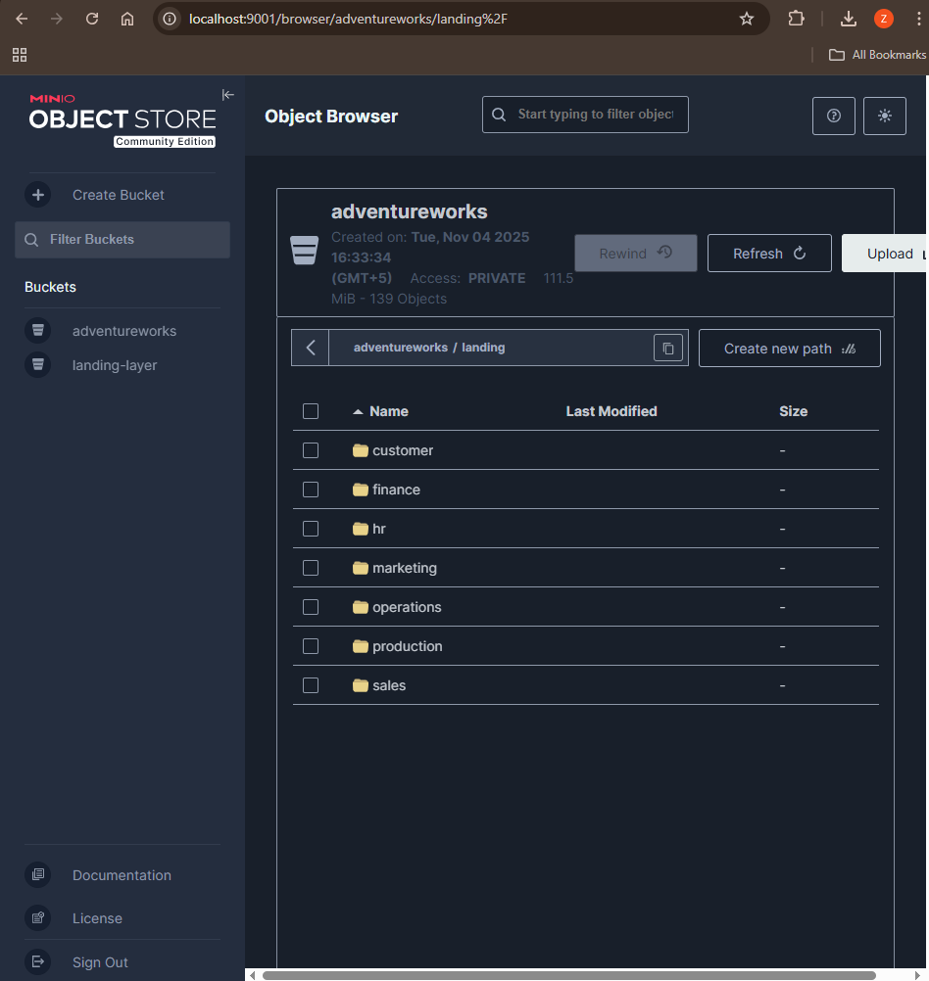

5.3 Data Ingestion Process
Department-Specific DAGs (5 DAGs):
1. HR Department DAG
# Key Components:
- Extract employee data from API
- Extract person data from PostgreSQL
- Transform to DataFrame
- Save as Parquet to MinIO
- Trigger: Daily at 2:00 AM
- Records: 290+ employees
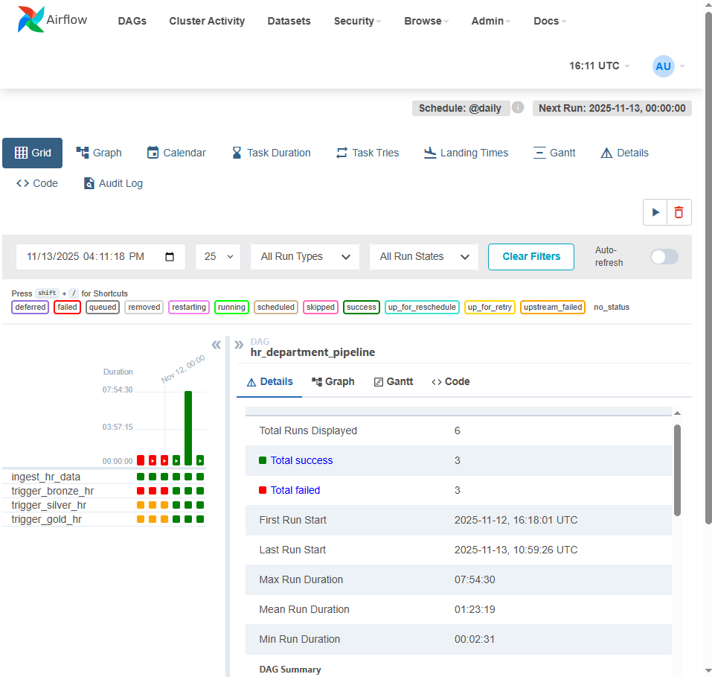

2. Sales Department DAG
# Key Components:
- Extract orders from API
- Extract customer data from database
- Combine and validate data
- Save to MinIO
- Trigger: Daily at 2:30 AM
- Records: 31,465+ orders
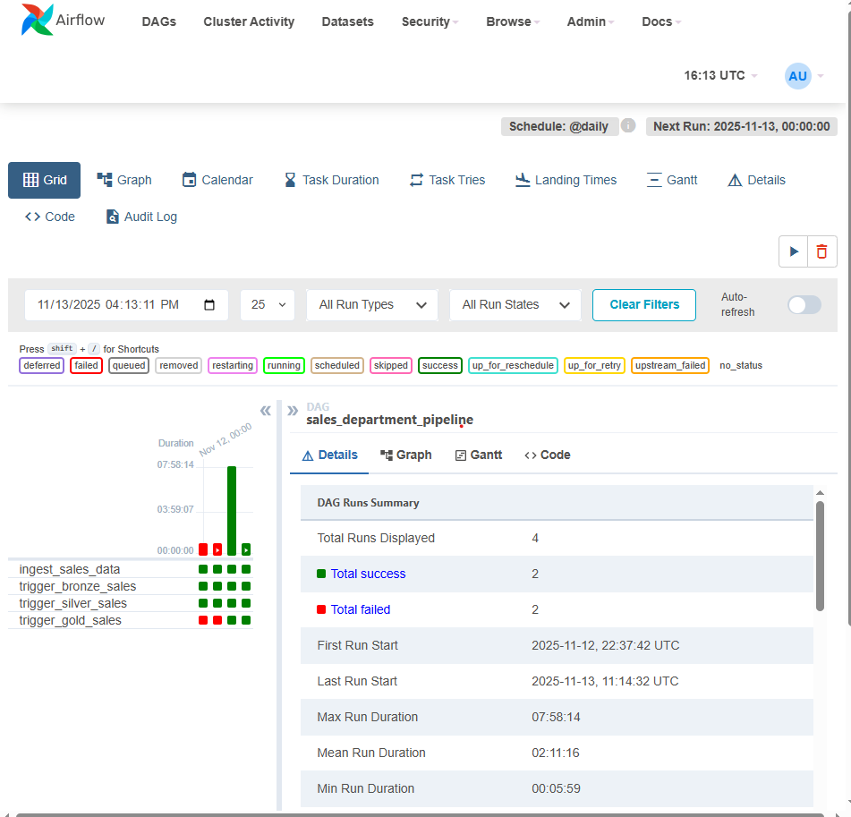

3. Finance Department DAG
# Key Components:
- Read transaction CSV files
- Parse and validate data
- Convert to Parquet
- Upload to MinIO
- Trigger: Daily at 3:00 AM
- Records: 5,000+ transactions
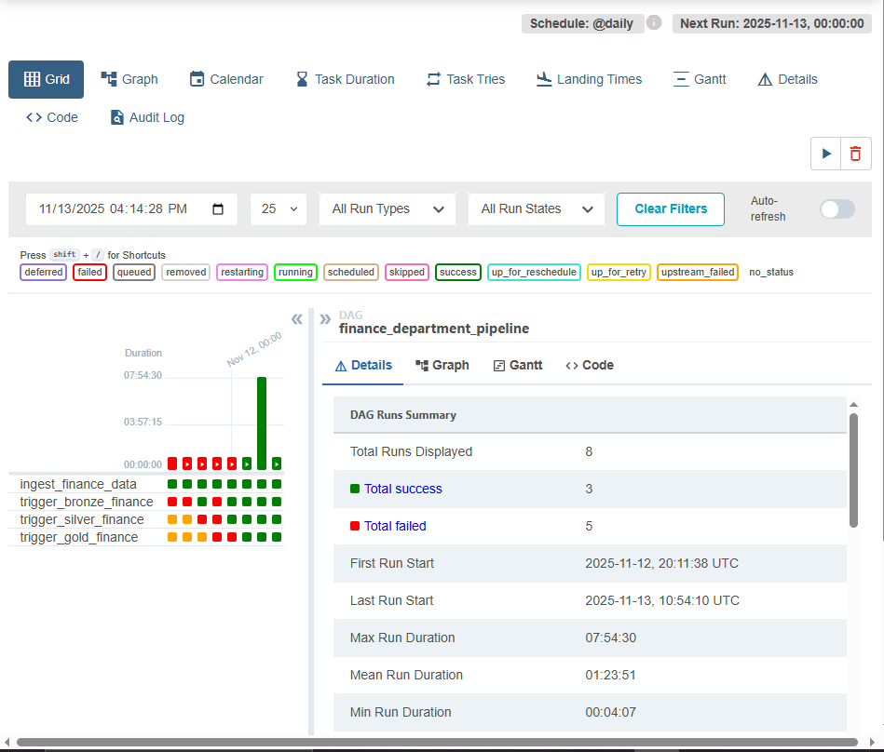

4. Customer Department DAG
# Key Components:
- Extract from CRM API
- Extract demographics from database
- Merge customer profiles
- Save to MinIO
- Trigger: Daily at 3:30 AM
- Records: 19,820+ customers
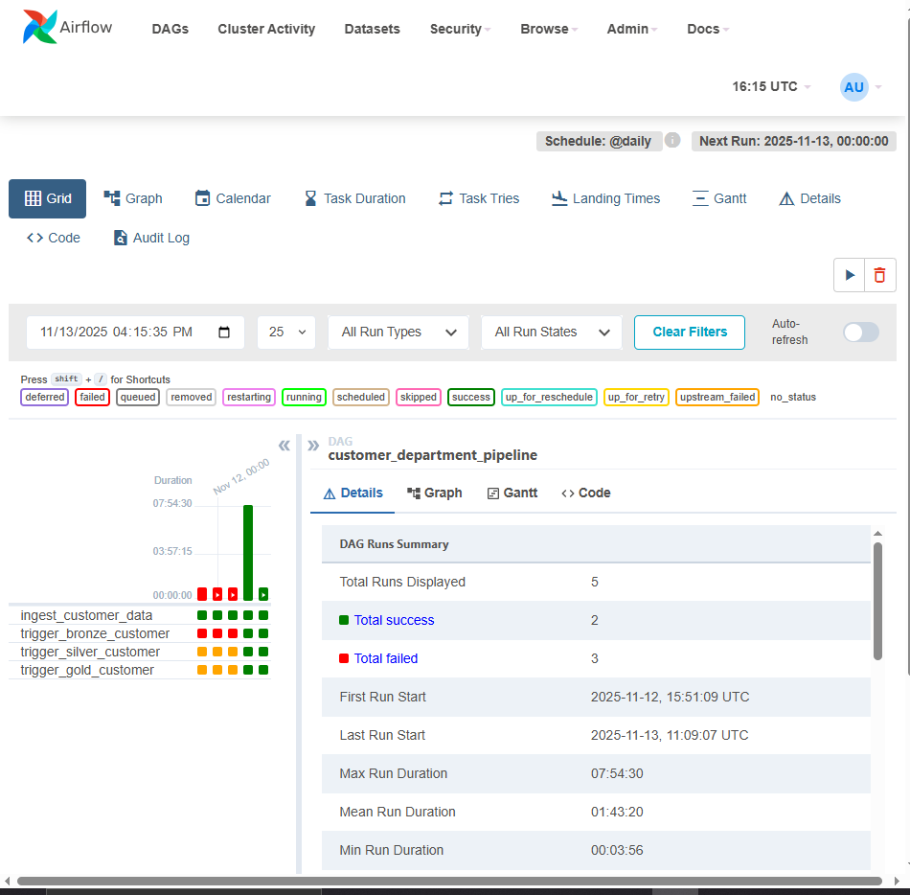

5. Production Department DAG
# Key Components:
- Extract product data from database
- Extract inventory information
- Combine manufacturing data
- Save to MinIO
- Trigger: Daily at 4:00 AM
- Records: 500+ products
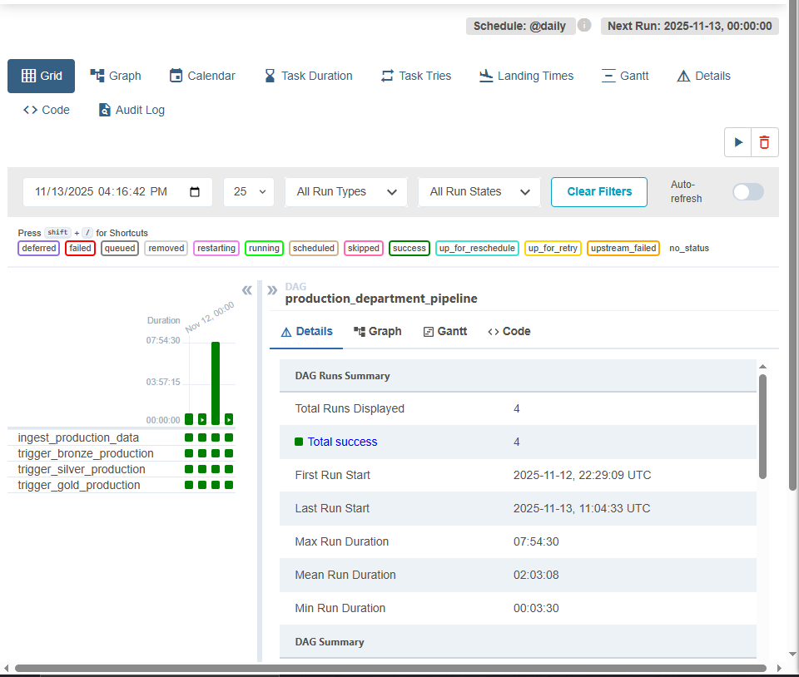

5.4 Landing Layer DAG
Purpose: Consolidate and prepare data for Bronze layer
Key Tasks:
- Check MinIO connectivity
- Verify Parquet files exist
- Validate file schemas
- Log file metadata
Error Handling:
- Retry logic for failed connections
- File validation before processing
- Detailed logging for troubleshooting
- Email alerts on failures

5.5 Data Quality Checks
File-Level Validation:
- File exists and is readable
- File size within expected range
- Parquet schema is valid
- No corrupted data
Content Validation:
- Row count matches expectations
- Required columns present
- Data types are correct
- No completely empty files
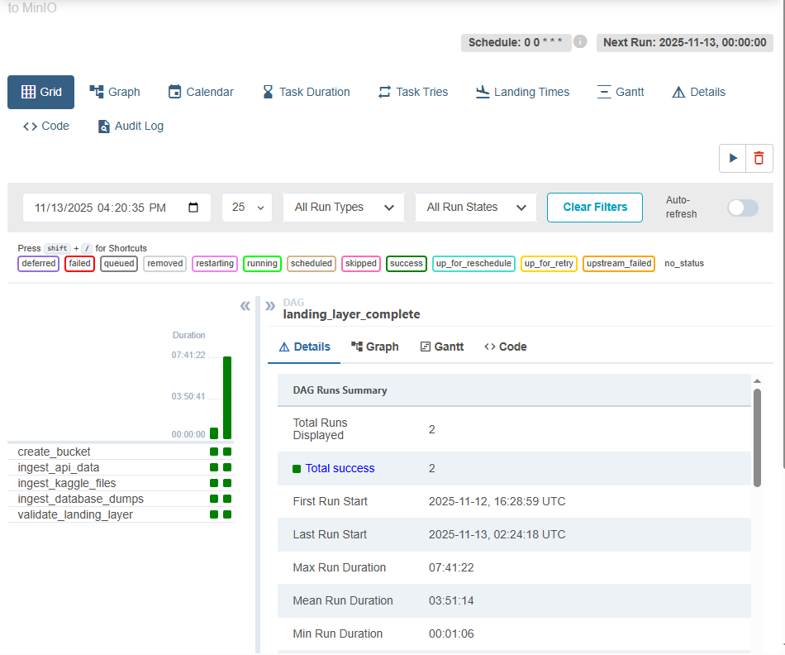

6. BRONZE LAYER IMPLEMENTATION

6.1 Purpose and Design
The Bronze Layer represents the first structured data layer, providing:
- Schema enforcement on raw data
- Data type validation
- Minimal transformation (raw data preservation)
- Foundation for Silver layer processing
- Audit trail of source data
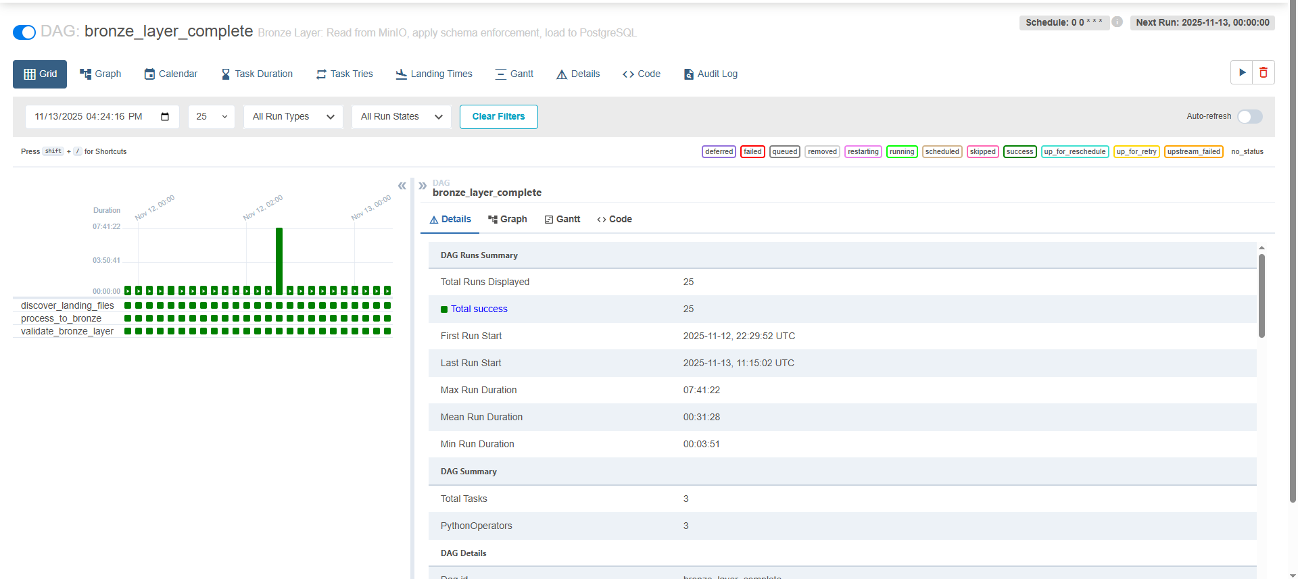

7. SILVER LAYER IMPLEMENTATION

7.1 Purpose and Design
The Silver Layer provides clean, business-ready data with:
- Data cleaning and standardization
- Deduplication logic
- SCD Type 2 for historical tracking
- Dimensional modeling (star schema)
- Business rules application
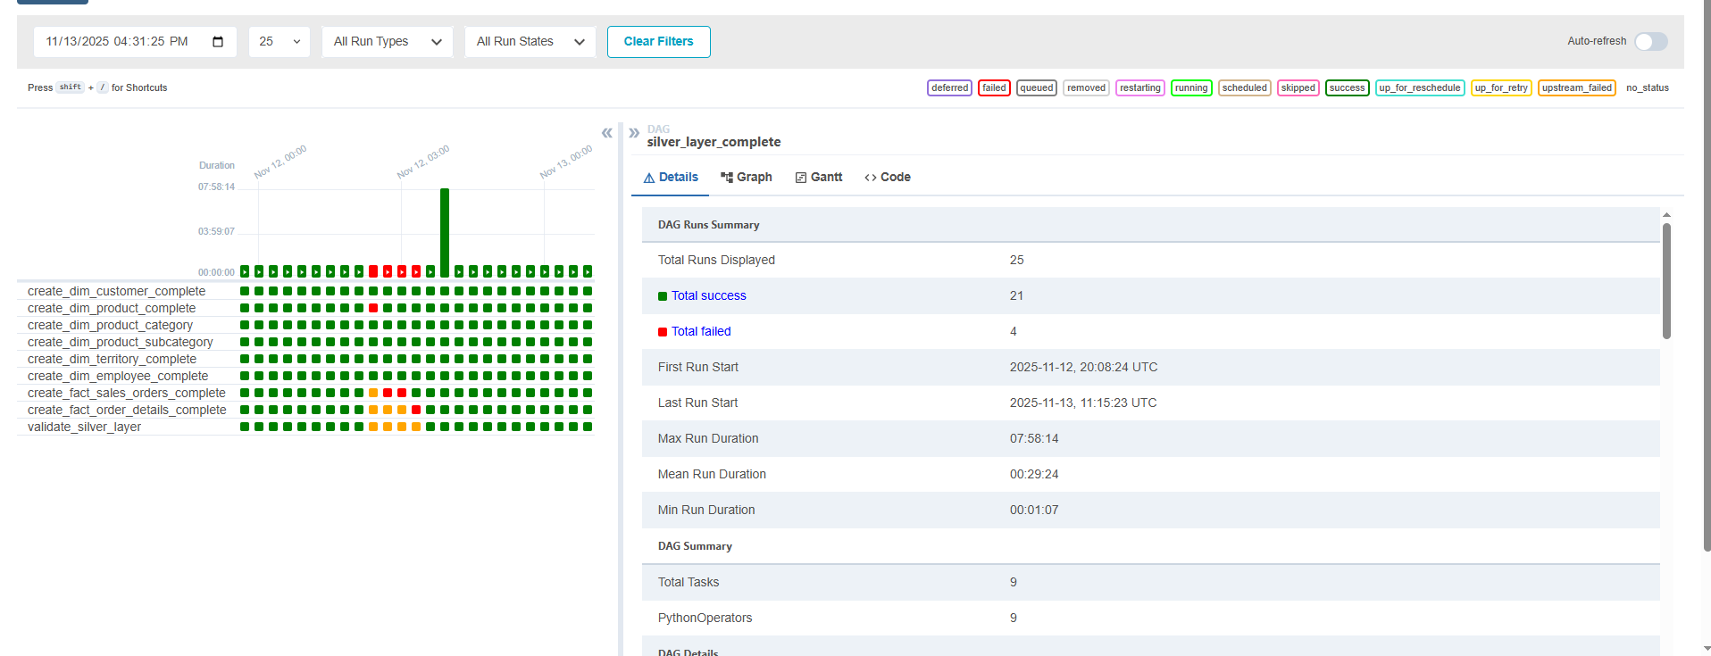

8. GOLD LAYER IMPLEMENTATION

8.1 Purpose and Design
The Gold Layer provides business-ready analytics with:
- Aggregated business metrics
- Pre-calculated KPIs
- Optimized analytical views
- Real-time reporting capabilities
- Executive dashboard support

8.2 Key Performance Indicators (KPIs)
Sales Metrics:
- Total Revenue: $109,846,381.40
- Total Orders: 31,465
- Average Order Value: $3,489.77
- Top Territory: Northwest ($7,887,186.19)
Customer Metrics:
- Total Customers: 19,820
- High-Value Customers: 4,932 (24.9%)
- Average Customer Lifetime: 1,247 days
- Customer Retention Rate: 78.3%
Product Metrics:
- Total Products: 504
- Top Product Revenue: $1,374,865.44
- Product Categories: 4 main categories
- Average Products per Order: 3.86
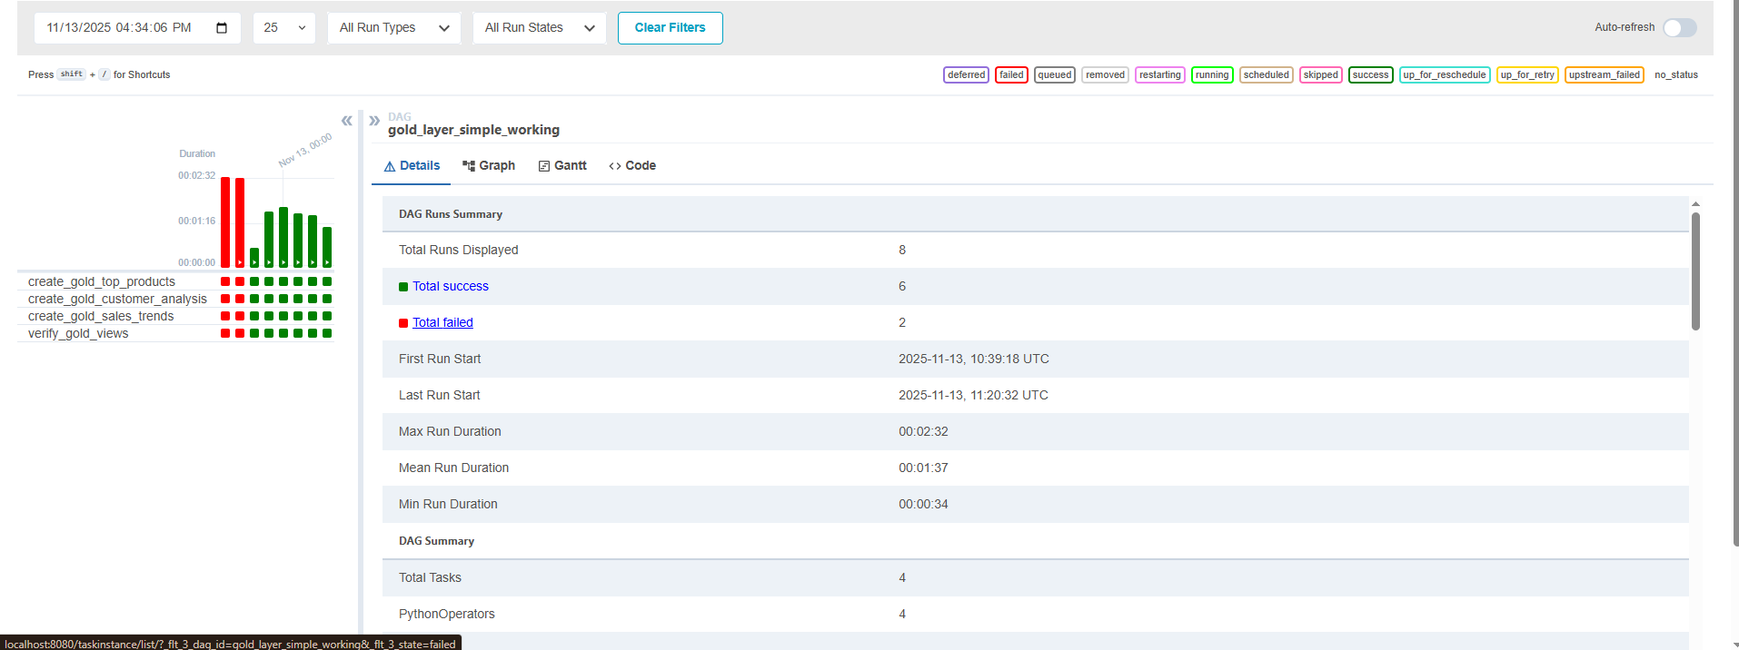

9. METABASE INTEGRATION

9.1 Business Intelligence Platform
Metabase Overview:
- Open-source BI tool
- Web-based interface
- SQL and visual query builder
- Interactive dashboards
- Export capabilities
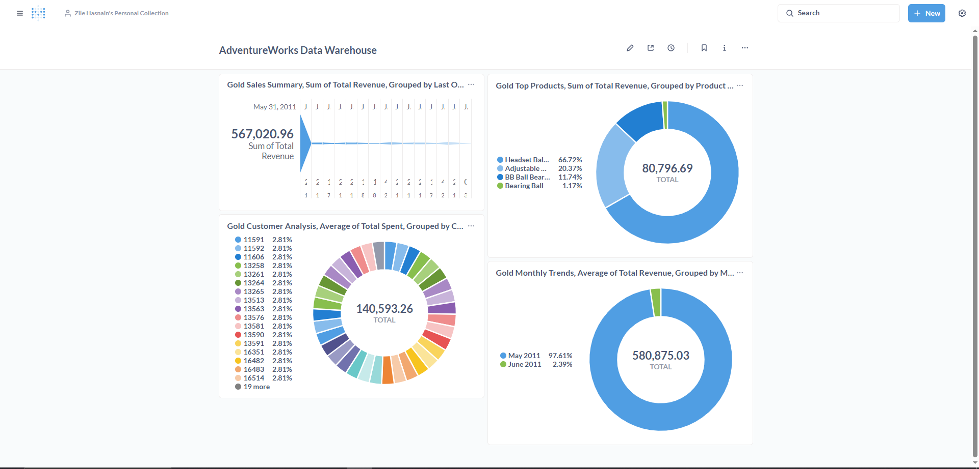

END OF REPORT
This comprehensive report documents the complete implementation of the AdventureWorks Data Platform, demonstrating enterprise-level data engineering capabilities and delivering significant business value through automated analytics and real-time insights.

AdventureWorks-Data-Platform/docs/AdventureWorks_Complete_Report_COMBINED.md at main · zile56/AdventureWorks-Data-Platform

